A. Clip: I stim, therefore I am [Loud Hands Blogaround]
-What does this video suggest about the creator’s childhood and adolescent experiences of growing up with utism?

-Unpack the idea of “self-loathing” in autism. Where does this come from? What are concrete ways that society can change to reduce this phenomenon?

-What makes this narrative effective?

B. Little Rainman: Autism -- through the eyes of a child by Karen L. Simmons
Written "to help autistic children along with their parents, teachers, and siblings to understand as early as possible the real 'world of autism.' This will enable children to get into an early intervention program as soon as possible. By doing so, they could have a very good prognosis as many children have had in recent years. My first thought was to write an operator's manual/handbook for my son's teachers or anyone involved in his life. This way they could more effectively know how to deal with his odd behavior in school or elsewhere. I could then simply hand out the book and say, 'This is Jonathan. Please read about him, as he is different than most people.'"
-Given the intended audience and mission above, discuss pros and cons of this children's book.

-How do you think this book would be received by other children with autism? By others?

C. Clip: A Parent’s Perspective- “Fixing” Autism
Make a list of words/phrases that stand out. Afterwards reflect on why they stood out to you.

-What do you notice about the language this parent uses?
-What are some artistic choices made in the making of this film? What effect did these details have?
D. I am Utterly Unique! Celebrating the Strengths of Children with Asperger Syndrome and High-Functioning Autism by Elaine Marie Larson
This ABC book "reminds young readers of the wonderful characteristics held by many with autism spectrum disorders."
-Who is the intended audience of this book? How can you tell?

-How do you think this book would be received by other children with autism? By others?

E. Clip: Rethinking Autism: Autism Support Group
From an advocacy and public health standpoint:
-How can we raise awareness about autism spectrum disorders and better support this community as a society?

-What misunderstandings need to be corrected about autism and how are we to do this?

F. The Kaleidoscope Kid: Focusing on the Strengths of Children with Asperger Syndrome and High-Functioning Autism by Elaine Marie Larson
This book was written "to help her grandson Sam, who has Asperger Syndrome, grow in self-awareness of his many capabilities. Elaine also hopes the book will help readers of all ages realize that people with Asperger Syndrome and high-functioning autism have numerous positive attributes and are similar to their peers in many ways."
-Given the intended audience and mission above, discuss pros and cons of this children's book.

-How do you think this book would be received by other children with autism? By others?

G. A recent study published in May 2022 by Weir et al. showed that "Autistic adults have poorer quality healthcare and worse health based on self-report data."
Based on reviewing the study's figure below:
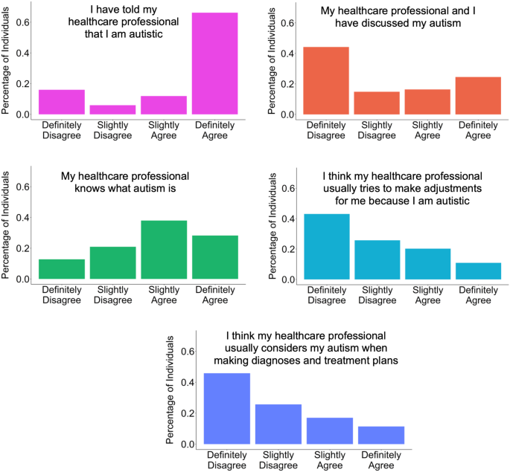

-Which statements surprise you? Make a list of barriers that might influence the healthcare of Autistic adults based on their self-reported experiences with healthcare professionals. Why do you think these barriers exist?

-What public health awareness and medical education is needed about neurodiversity and autism for healthcare professionals?

-What clinical systems could be put in place to reduce health inequity for Autistic adults?

-How could healthcare systems be designed to embrace neurodiversity from a policy standpoint?

